McMaster University

Dept. of Electrical and Computer Engineering

COMP ENG 4TL4 - Term I (Fall) 2023

# **Lab 3 - Resampling, Reconstruction and the DFT**

**Demo Date: Oct. 30**

**Due Date: Nov. 12**

**Tianze zhang 40028135**

**Xiang li**

# [**zhant22@mcmaster.ca**](mailto:zhant22@mcmaster.ca)

# [**lix289@mcmaster.ca**](mailto:lix289@mcmaster.ca)

**Experiments:**

(a)

**1. Images, resampling and reconstruction**

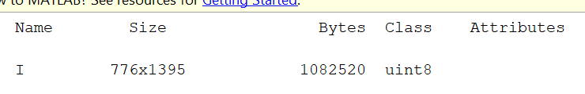

**(b)**

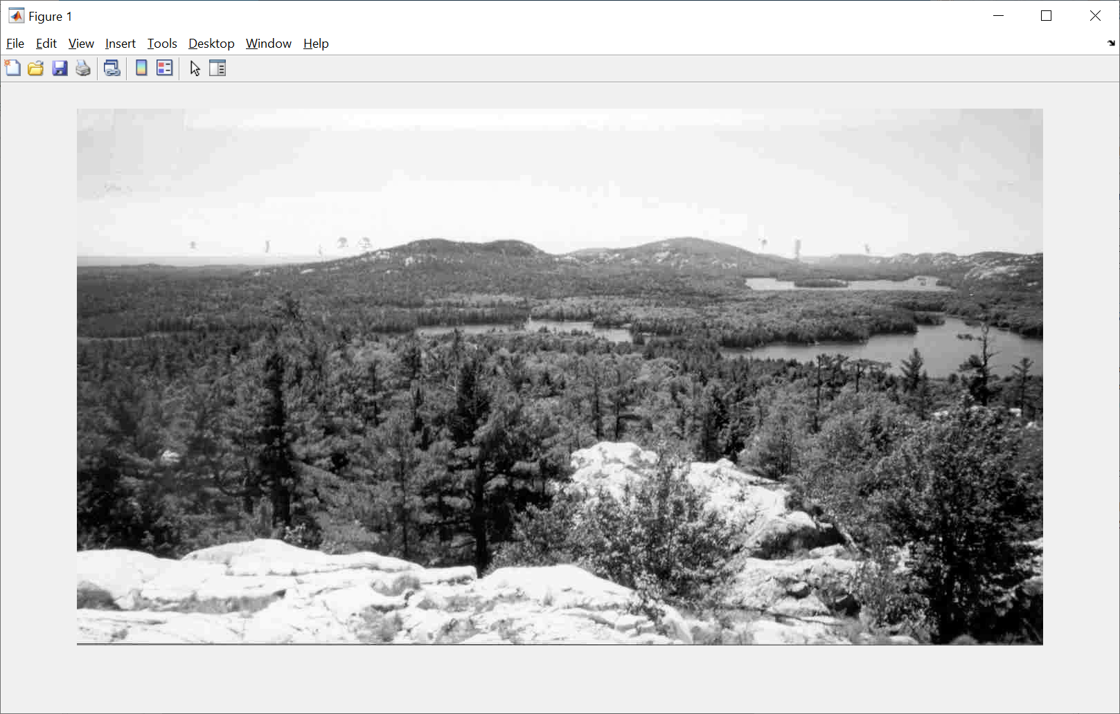

**(c)**

**gary:**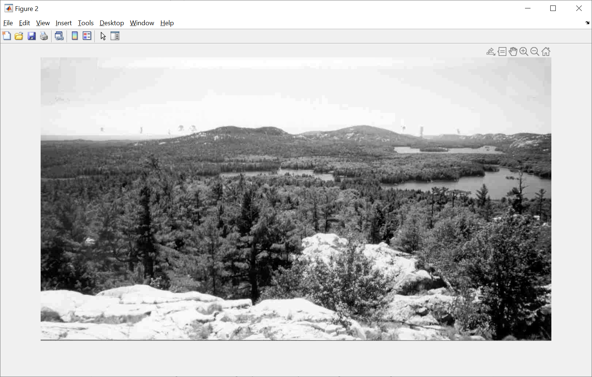

**1-gary**

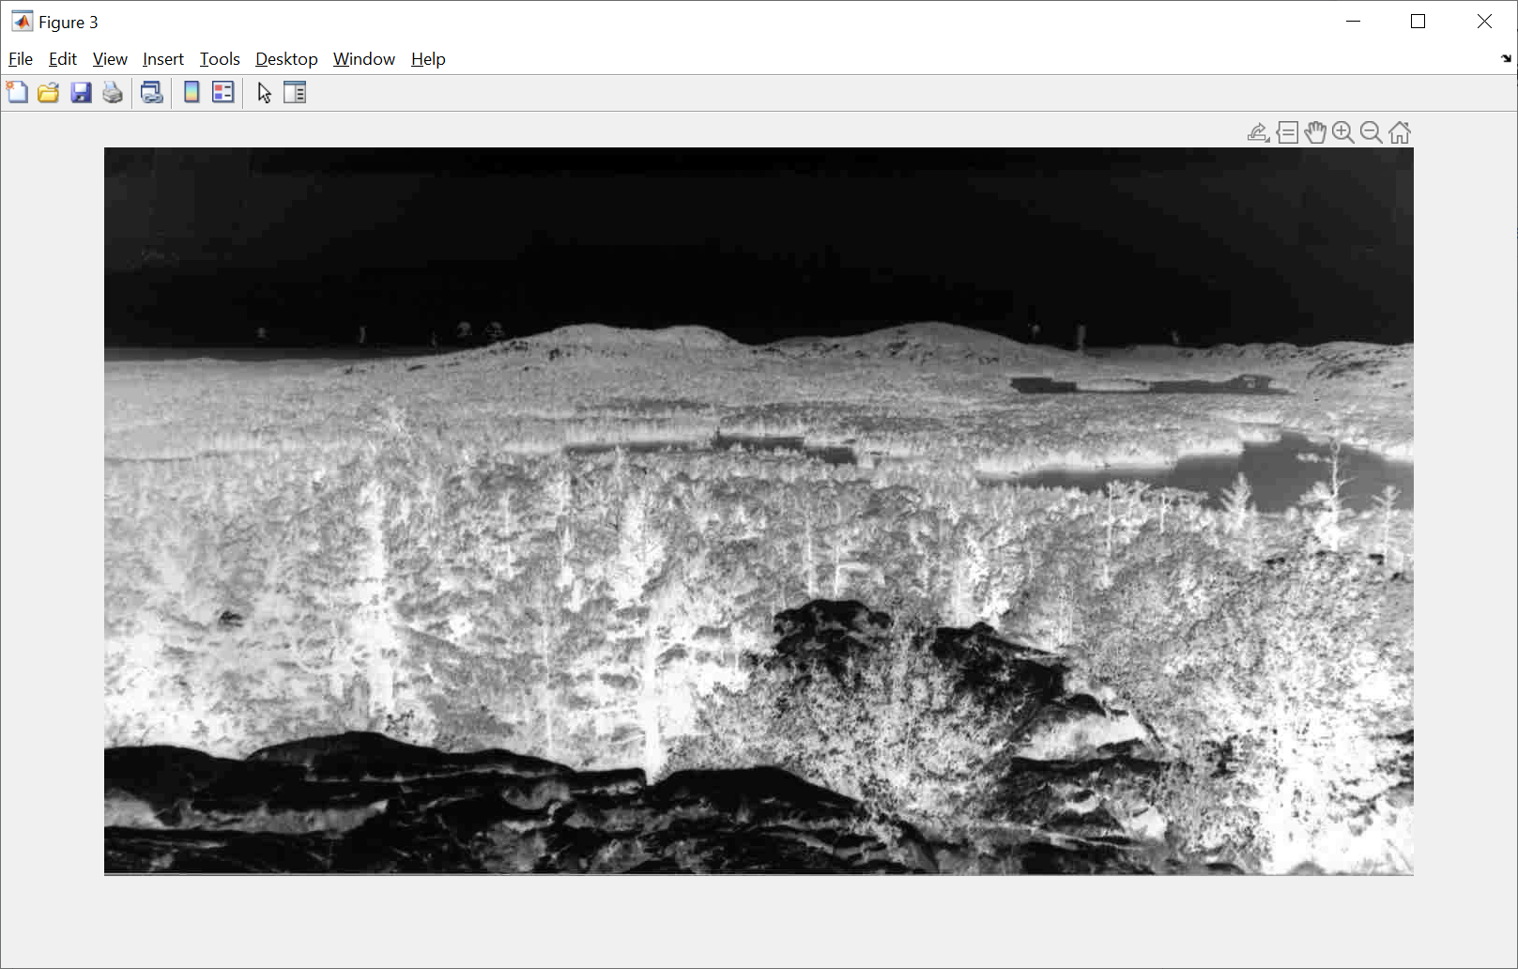

C: What effect does this have on the image

A: there is no change on the gray, if (1-gray) the color will inverse, black to white.

D_i: with ⅕ the pic will one sampling the first point every other points.

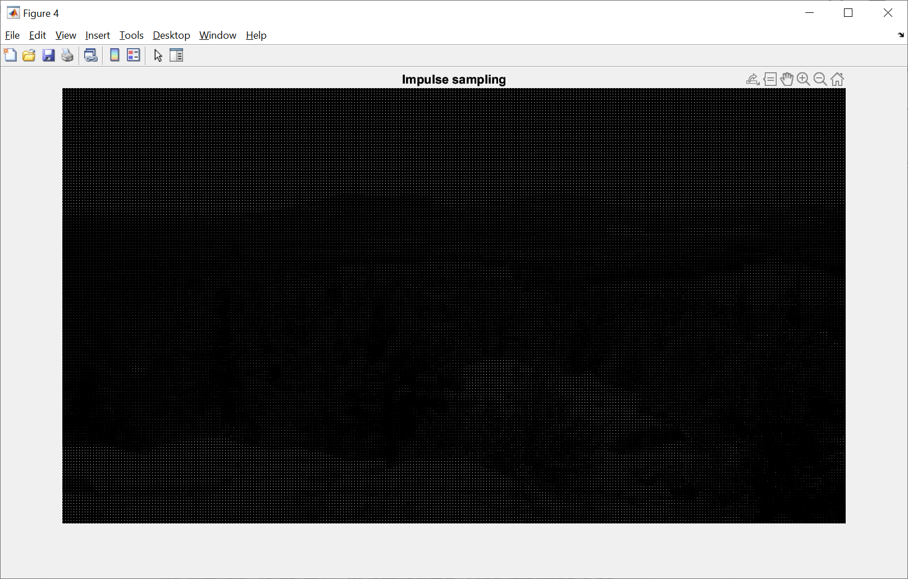

D_ii : with downsampling, the width of the pic is divided by 5 times.

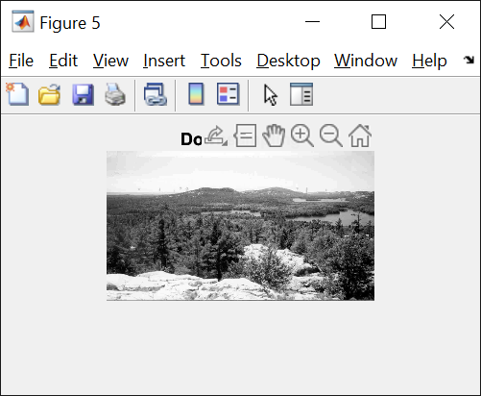

D_iii: time the width of the pic from D_ii 5 times to scratch the pic back to the original width.

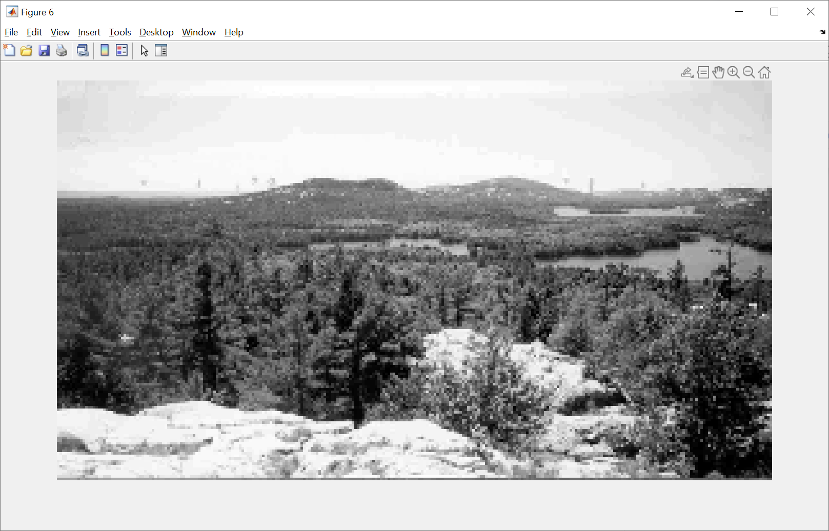

D_iv:

Using the already distorted picture to restore the original picture as close as possible and we can see the resolution is better.

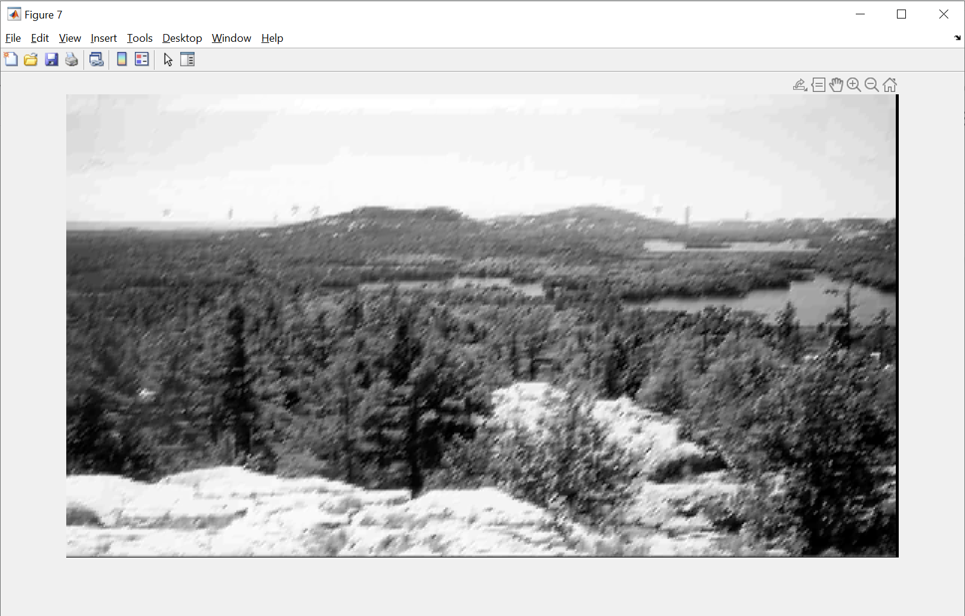

E: seems like D_iv is the best looking pic based on fidelity.

**2. Introduction to the DFT**

**(a)**

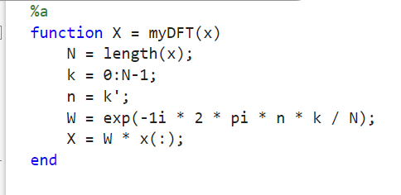

**(b)**

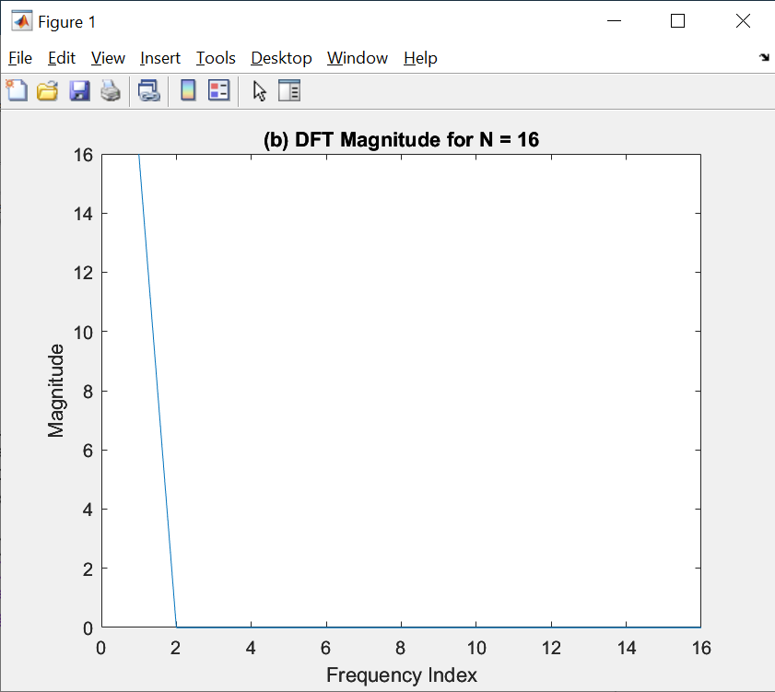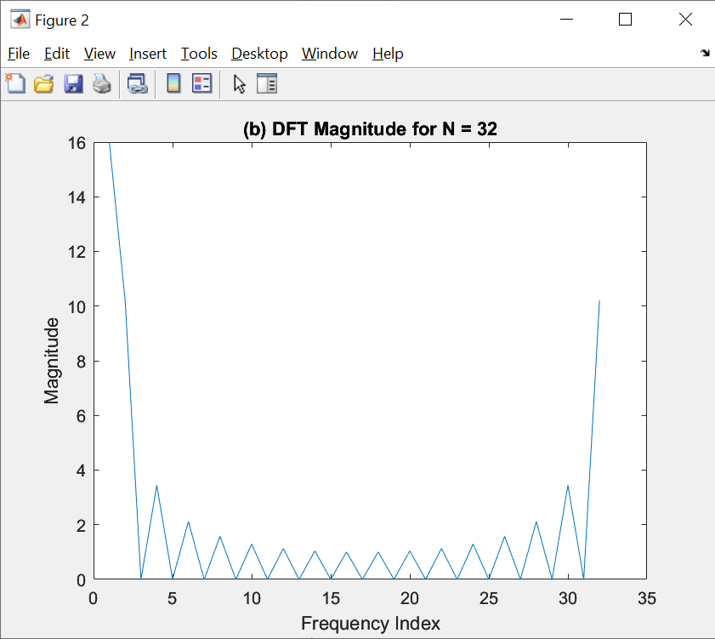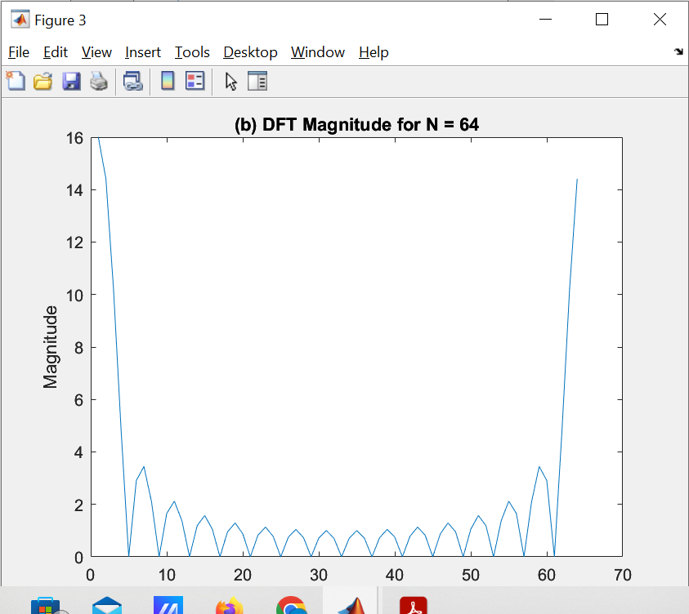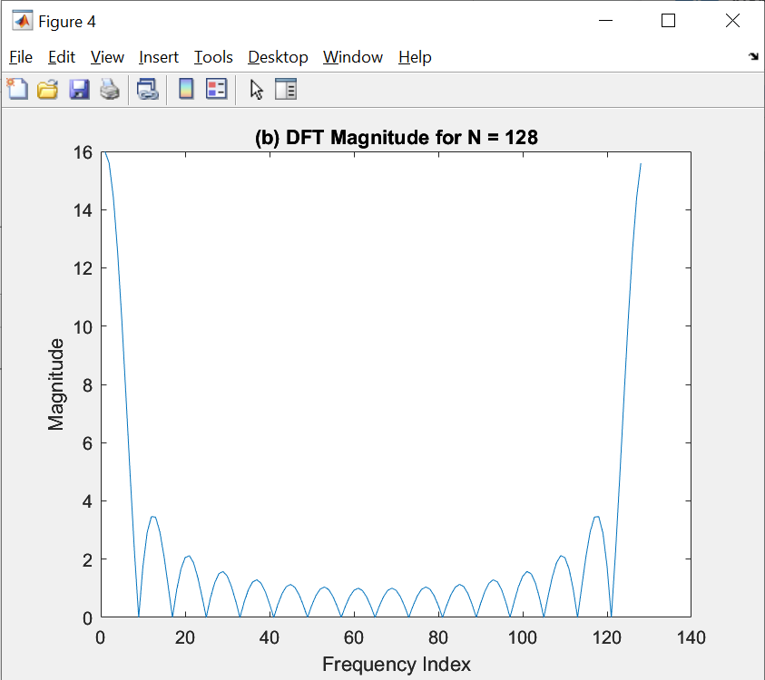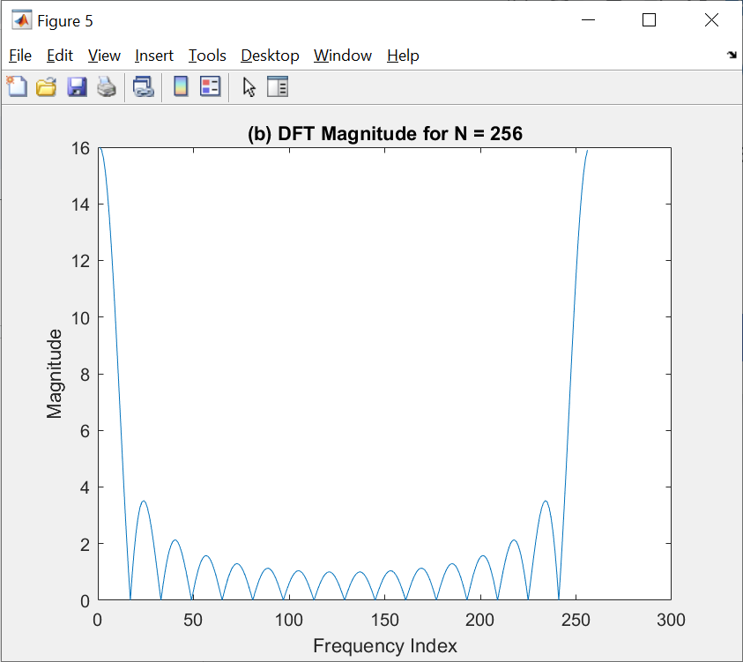

C:

With N =16 we lose all the information of the signal.

With N=32 we can see the info but the signal is sharp

With N=64 we can the shape is less shape than when N = 32

With N = 128, the curve of the wave is smooth out

With N = 256, the curve of the wave is really smooth

This is expected, as the N increase, we have more point in the DFT signal, so the curve is more smooth.

(c)

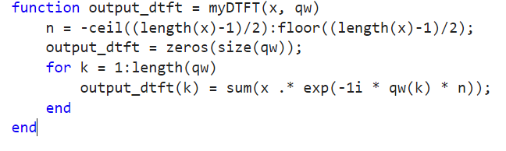

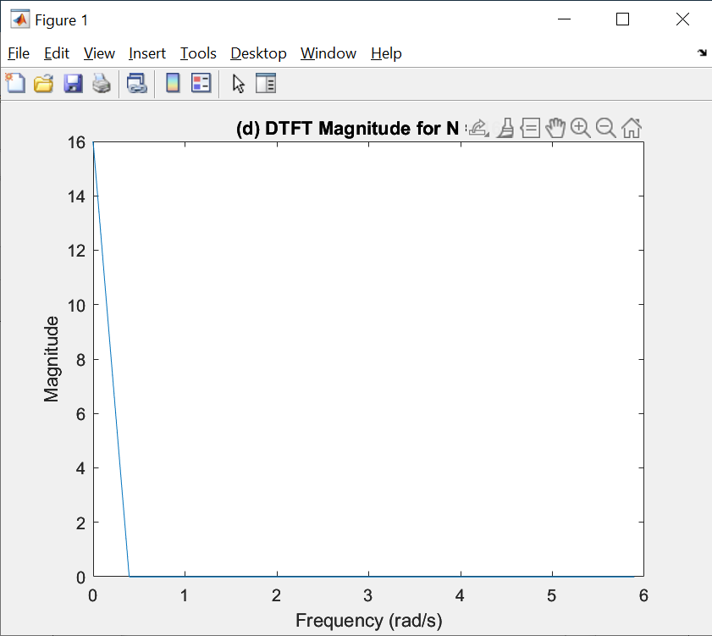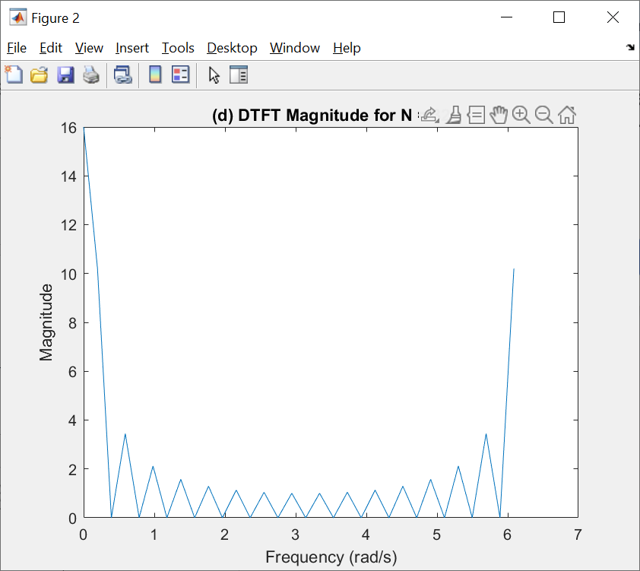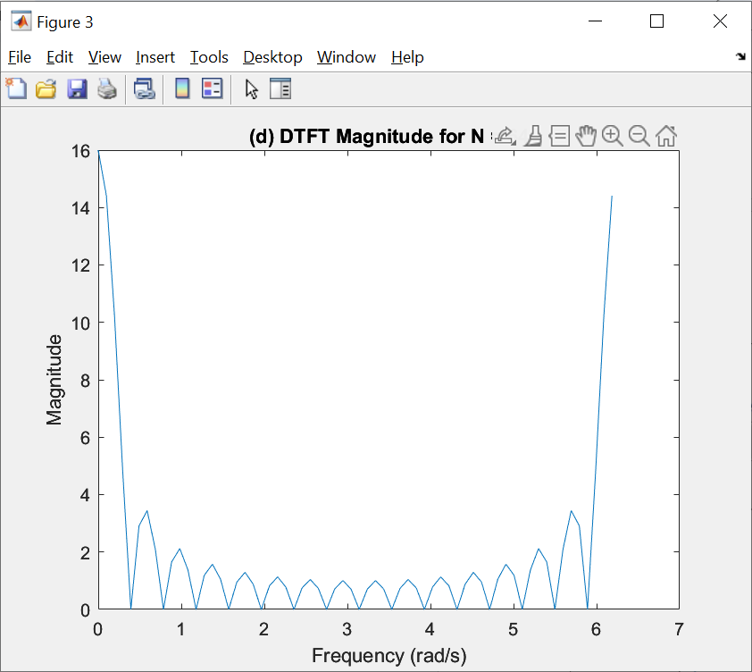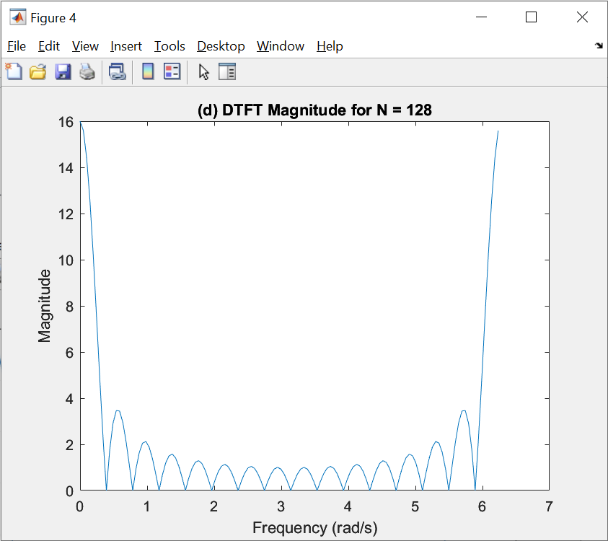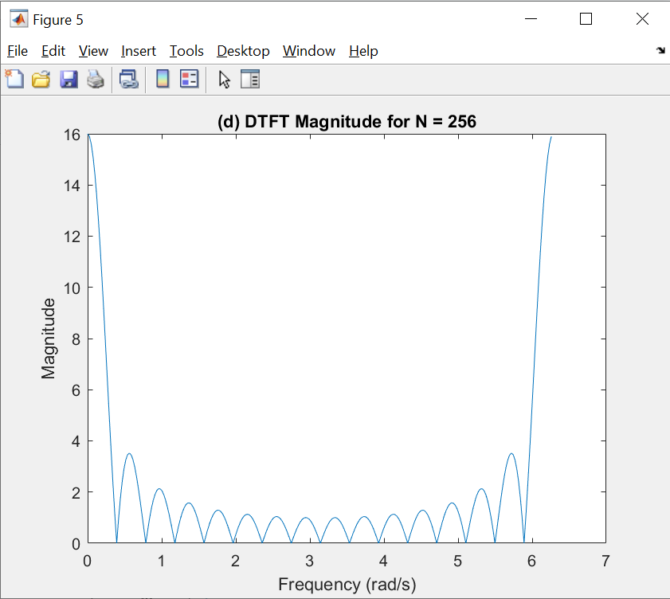

D: in order to return the same outputs as the DFT, we set the w to 2 * pi * (0: N-1)/N which is the same as DFT. the increasing N behave the same as what we have in DFT

(d)

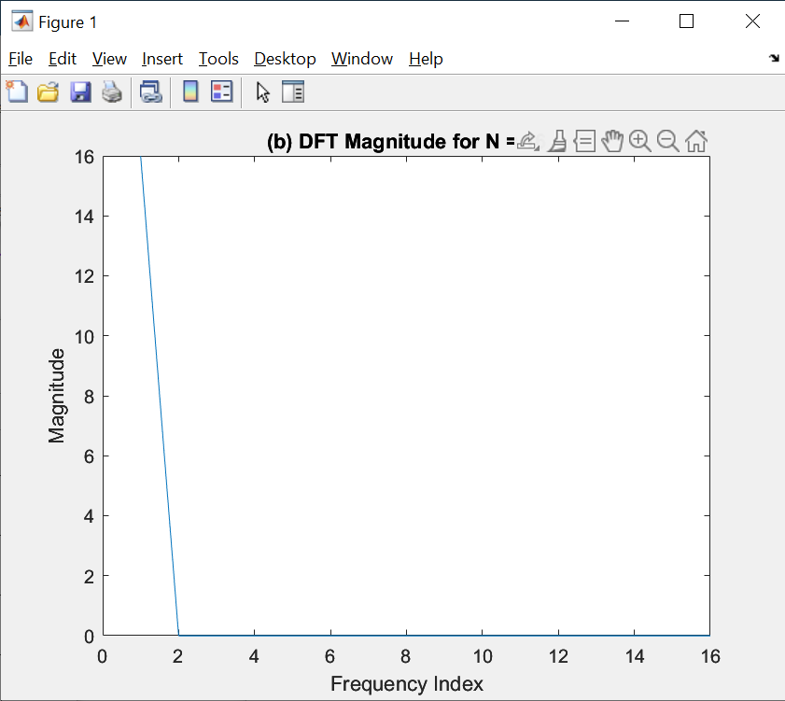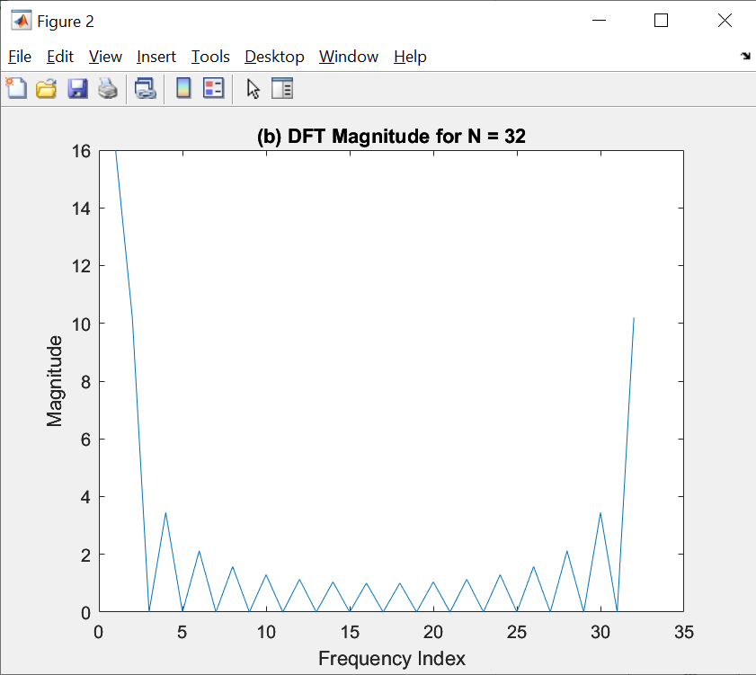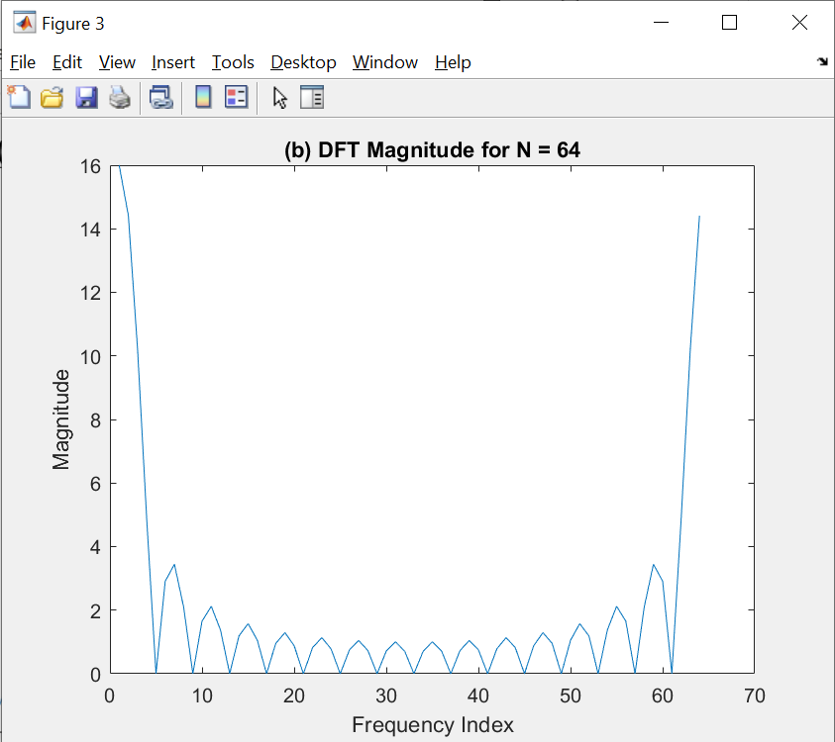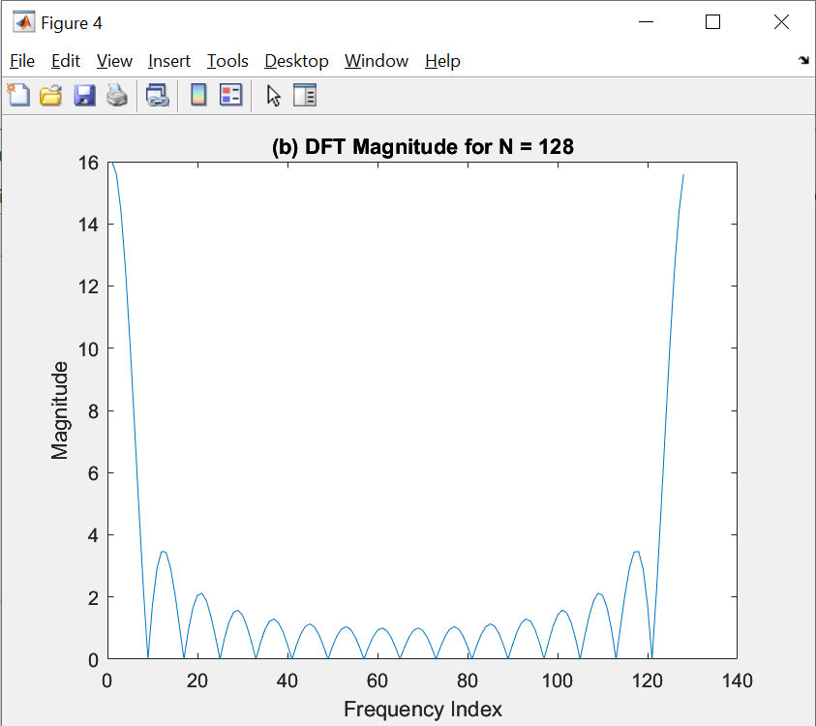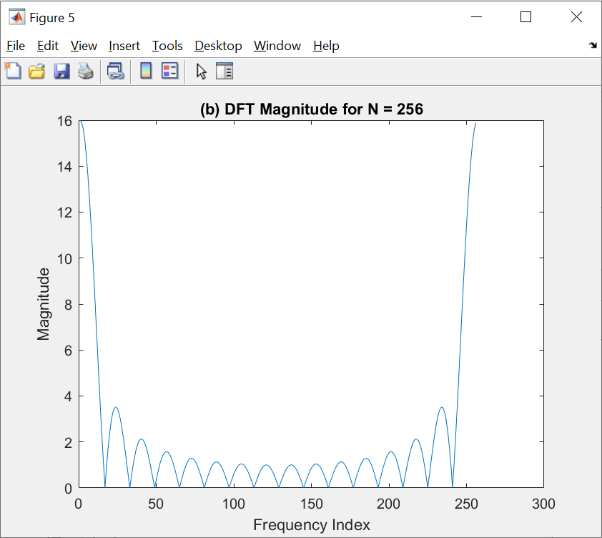

When increasing N, the curve is more smooth.

**3. FFT based speech recognition**

**(a)**

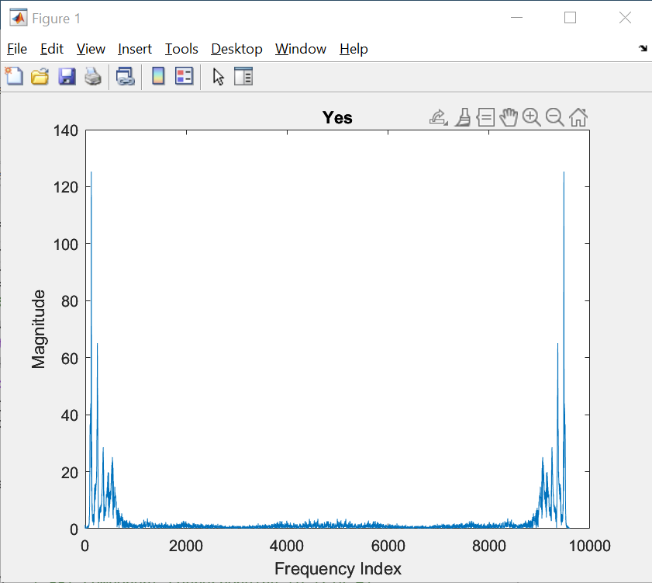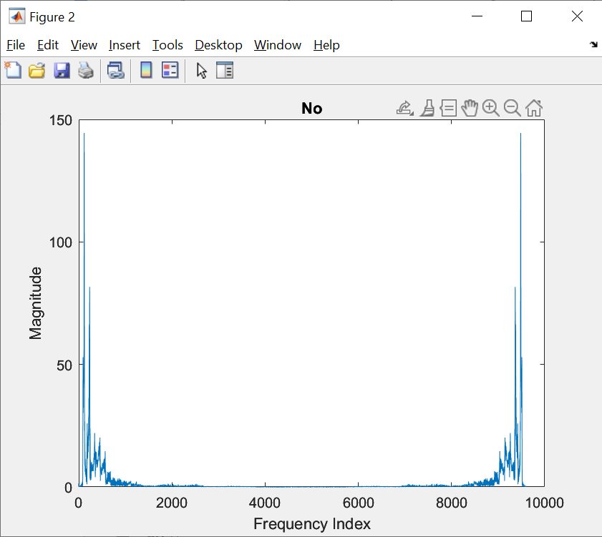

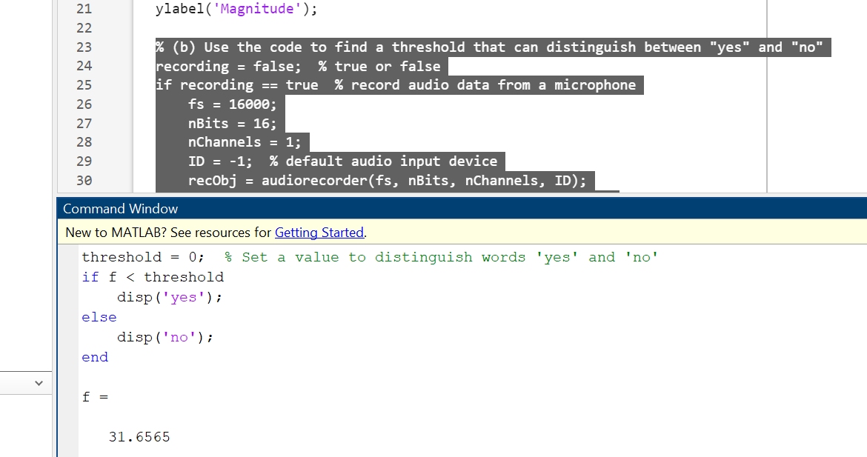

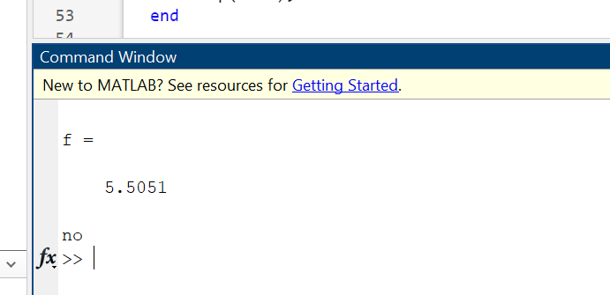

B: the threshold we assume is 10, since when we import Yes.wav, the feature is around 5, when we import No.wav, the feature is way bigger than 12, so we choose 10 as the middle point for the threshold.

C: for the SpeechRecognition code, we first modify the threshold_mag to 4000000, which is kind like the noise cancellation of the input signal, the DSP board will only process the signal when the input has a higher magnitude than the threshold.

The threshold of the feature is 5, since when I said Yes, the feature is about 2 to 3, when you say NO, the feature is around 12, so with a feature of 5, we can get the expected behavior.

